Estimation Of Business Expenses-Project

documentation

1.Introduction

1.1 Overview

Our project deals with business expenses and provides a visual exploration of the

various expenditures incurred by different businesses. It showcases the distribution of

expenses, identifies key cost drivers, and highlights areas of potential optimization or

concern. The visual representations allow for intuitive analysis, facilitating a deeper

understanding of expenditure patterns and their implications for business performance.

Decision-makers, financial analysts, and stakeholders can gain valuable insights into the financial health of businesses, identify areas of inefficiency or opportunity, and make informed decisions to optimize resources and drive growth.

1.2 Purpose

The purpose of an estimate is to help a business plan for and successfully complete

projects. Estimates help small businesses draw up budgets, evaluate cash flow and

manage client expectations.

1. Problem Definition & Design Thinking

Problem Understanding, also known as Problem Definition or Problem Identification, is the initial and critical phase of any data analysis or problem-solving process. It involves gaining a clear and comprehensive understanding of the problem at hand, its context, scope, and objectives

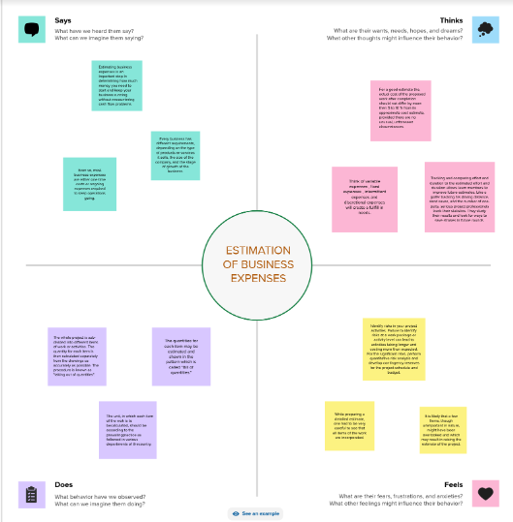2.1 EMPHATHY MAP

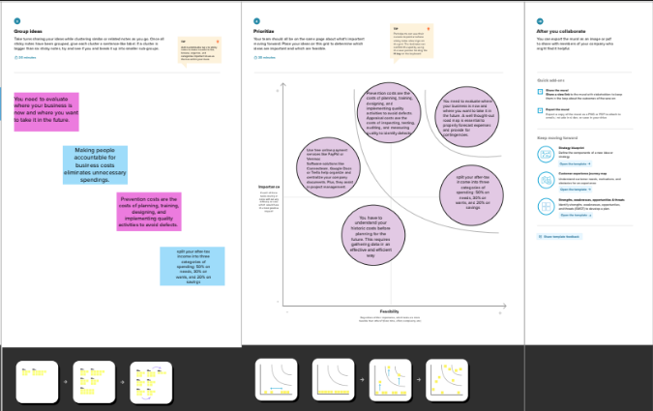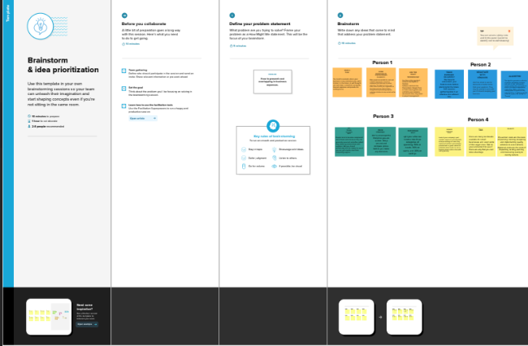.

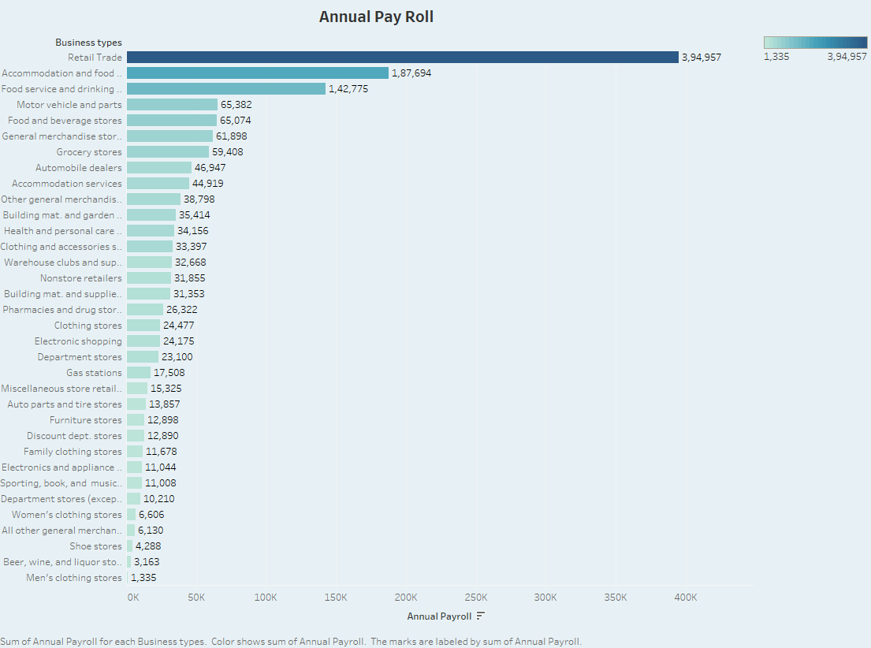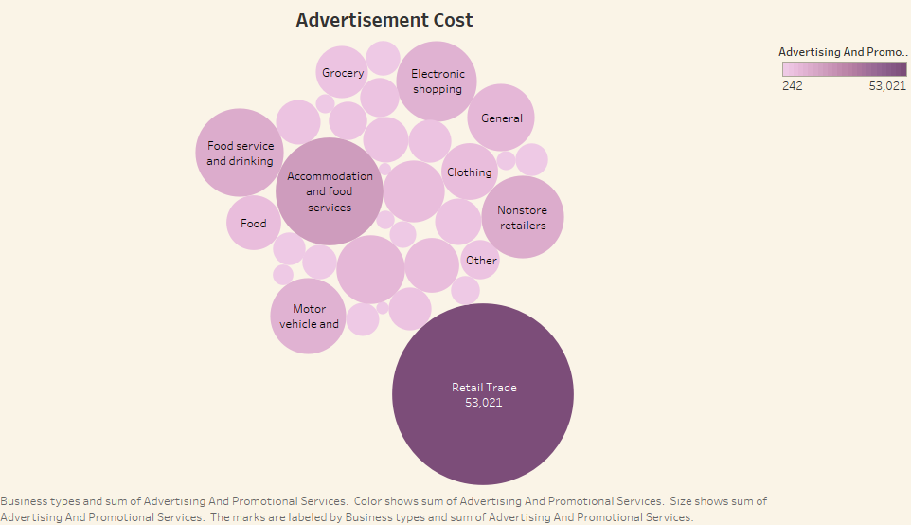3.RESULT

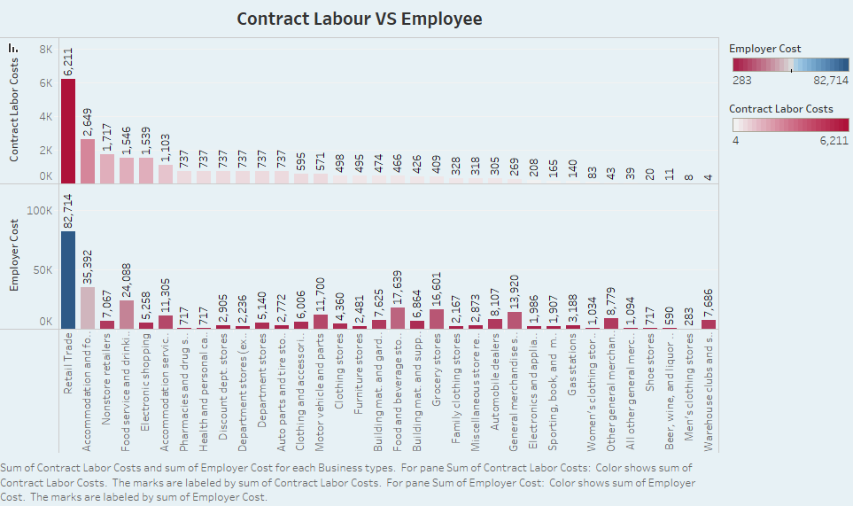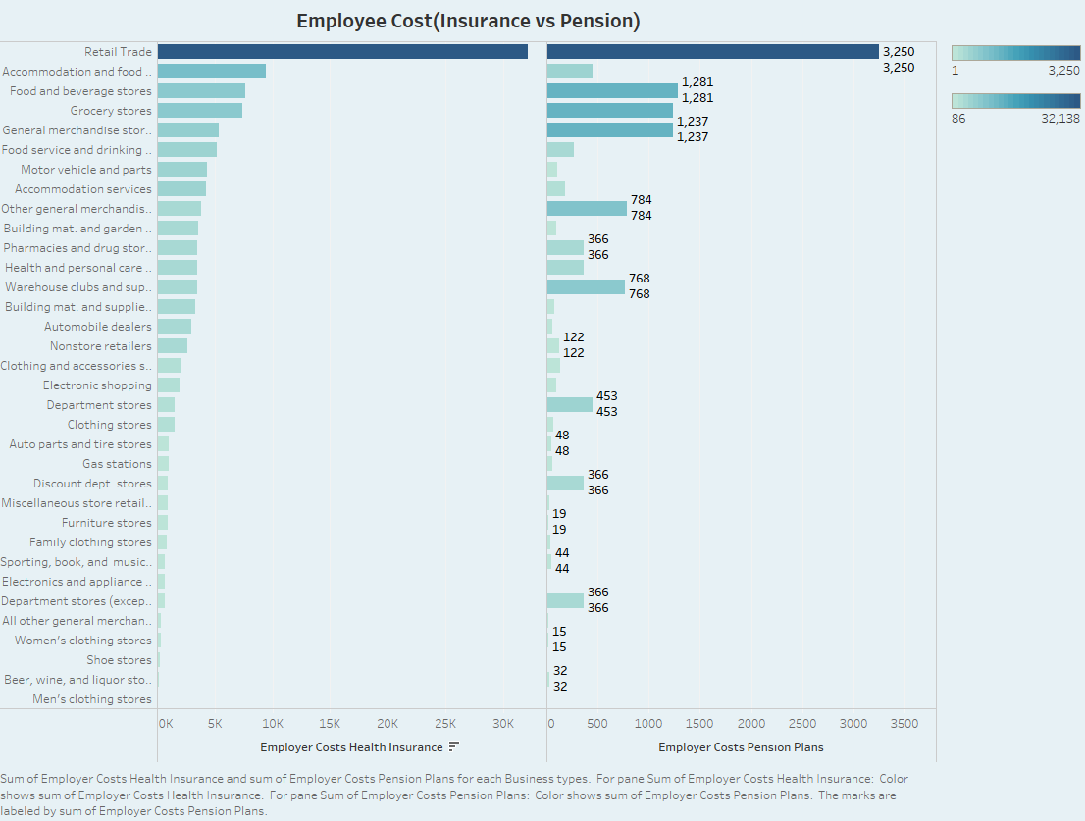

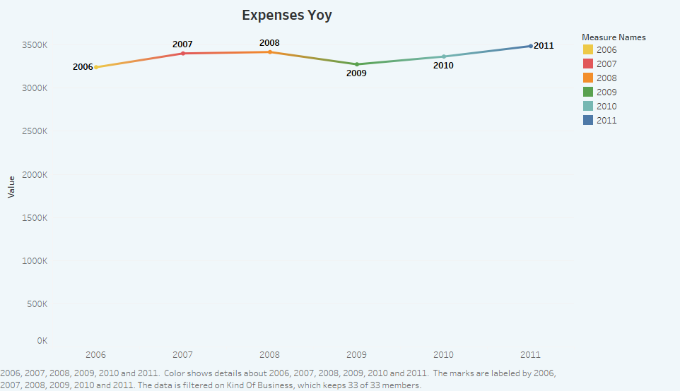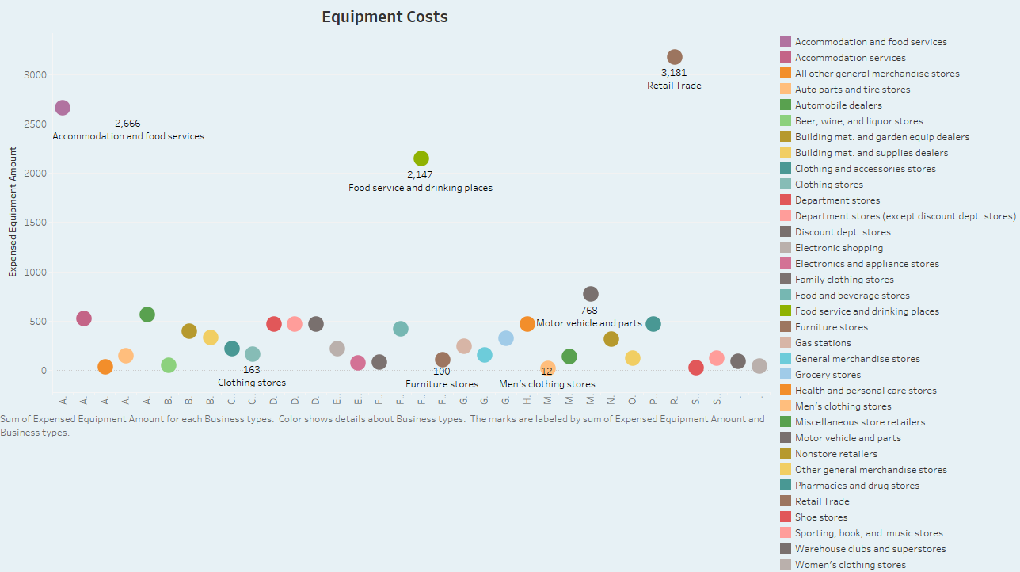

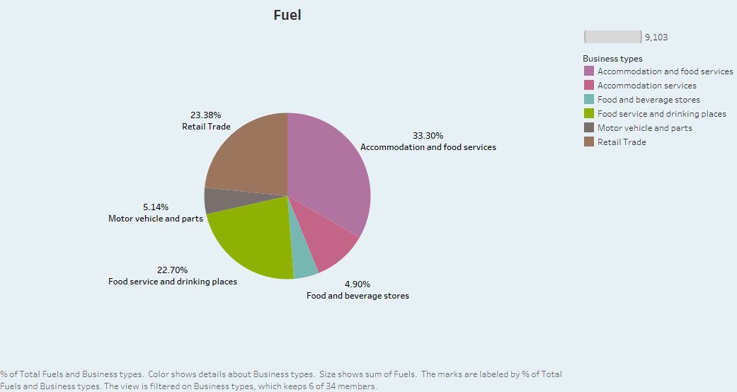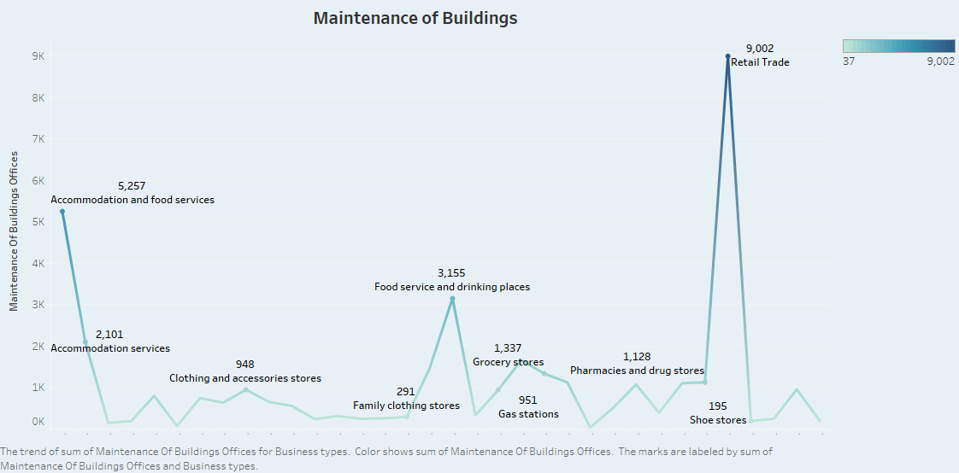

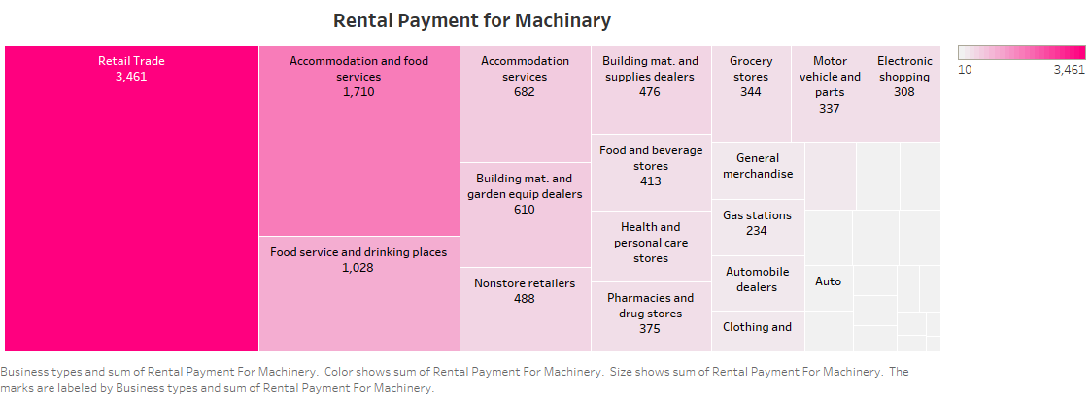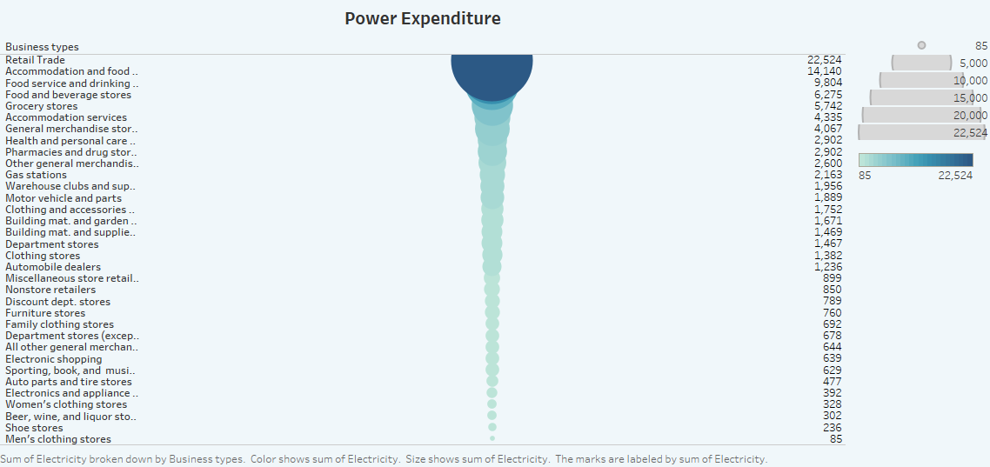

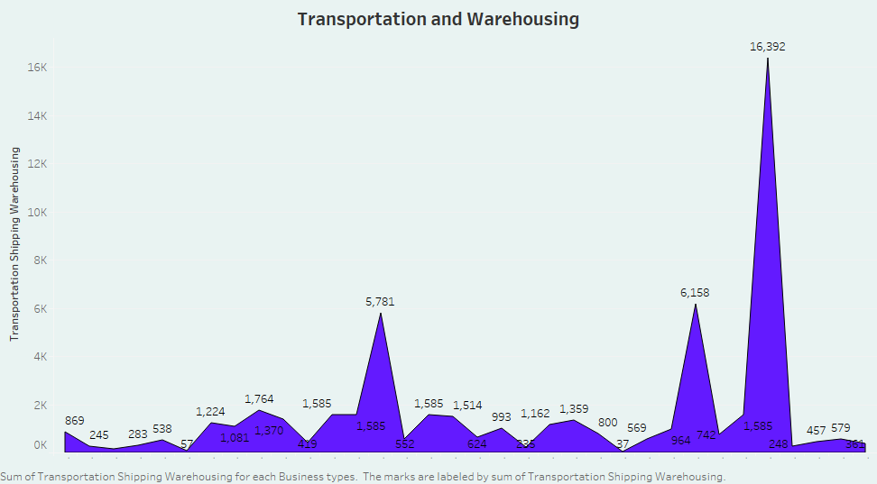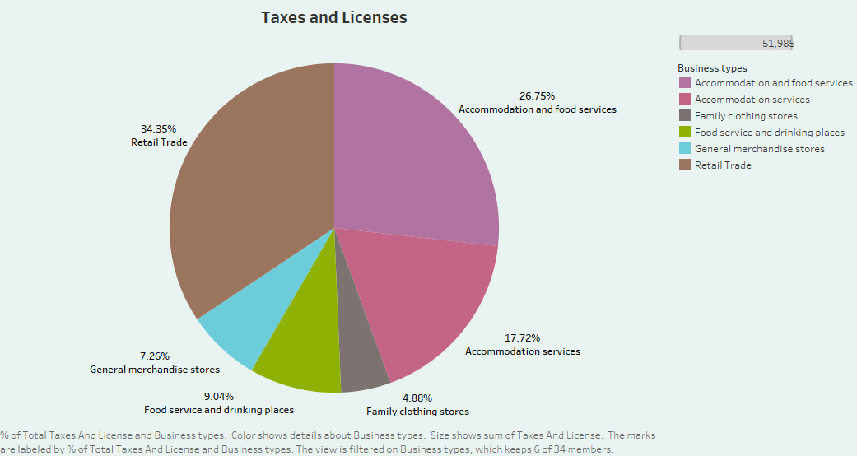

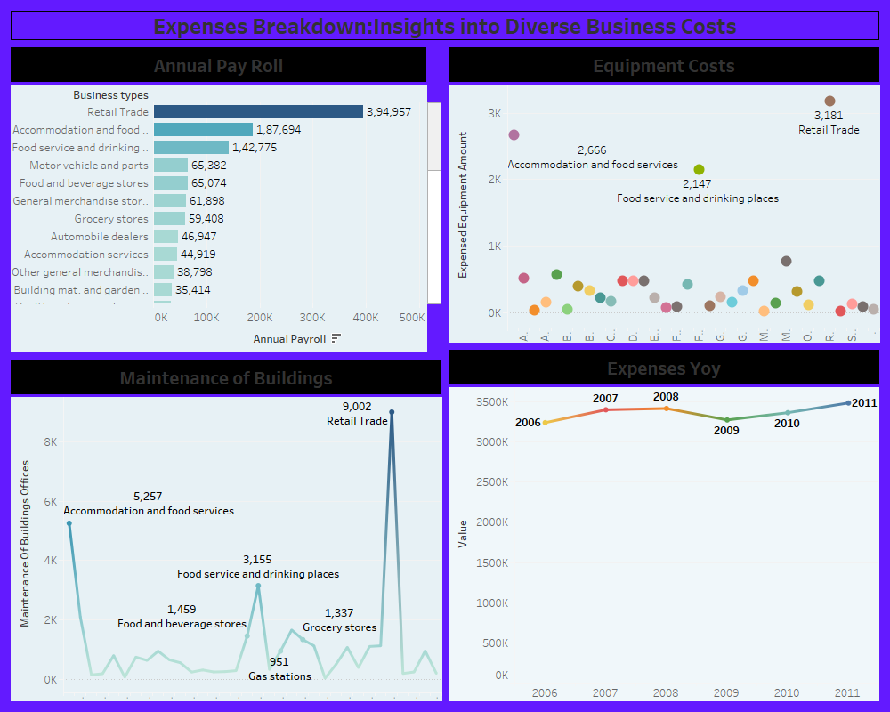

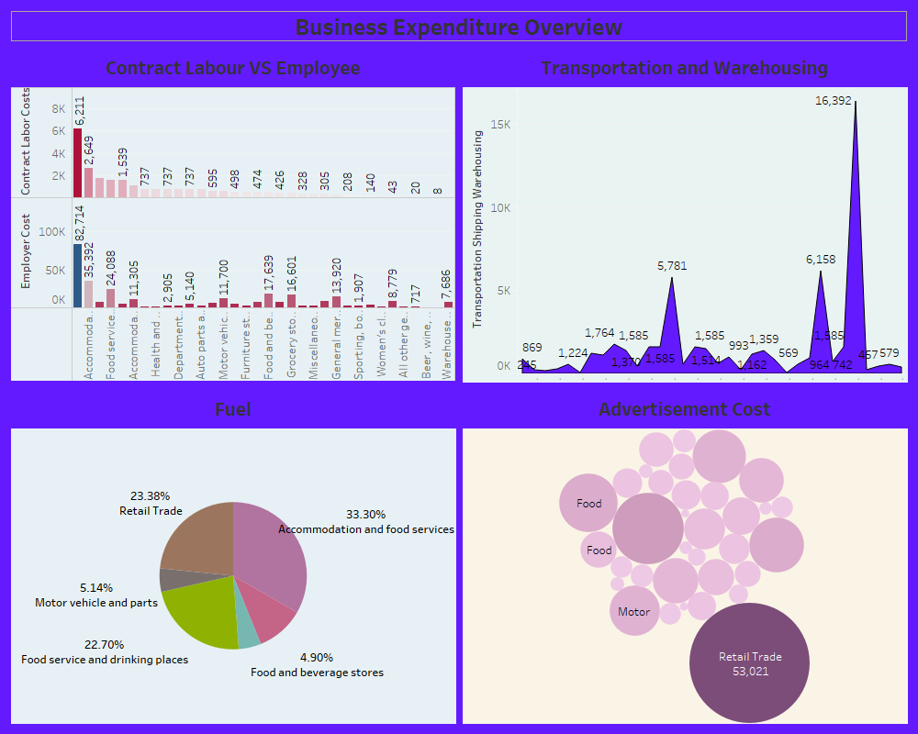

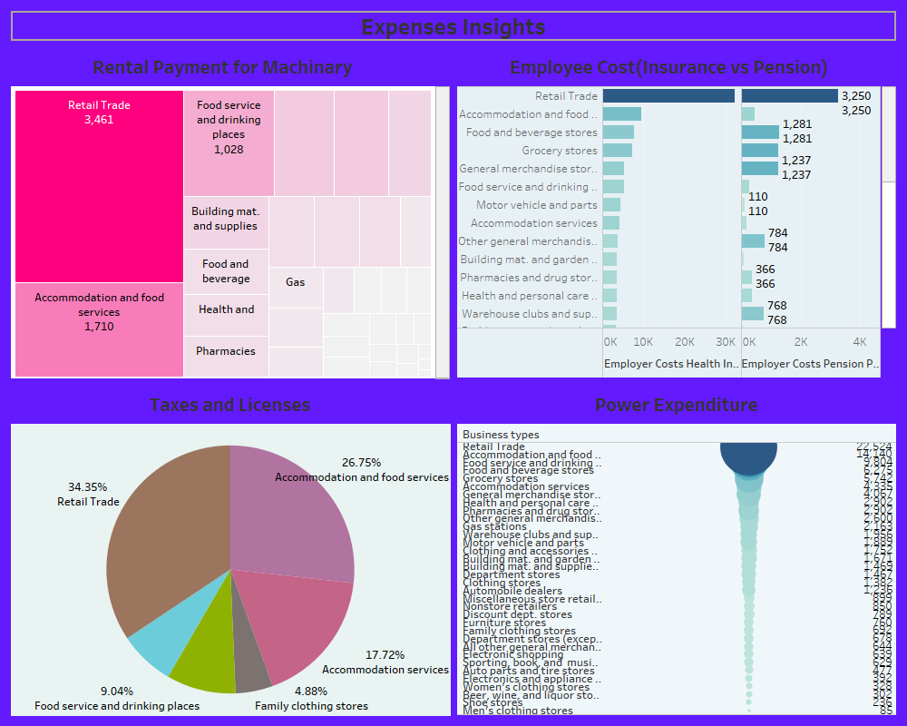

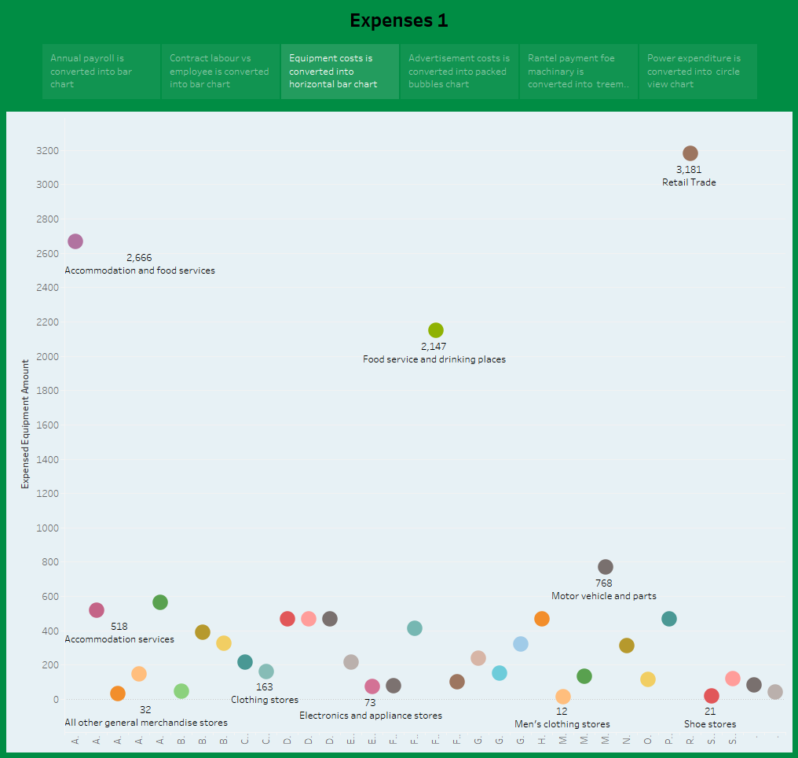

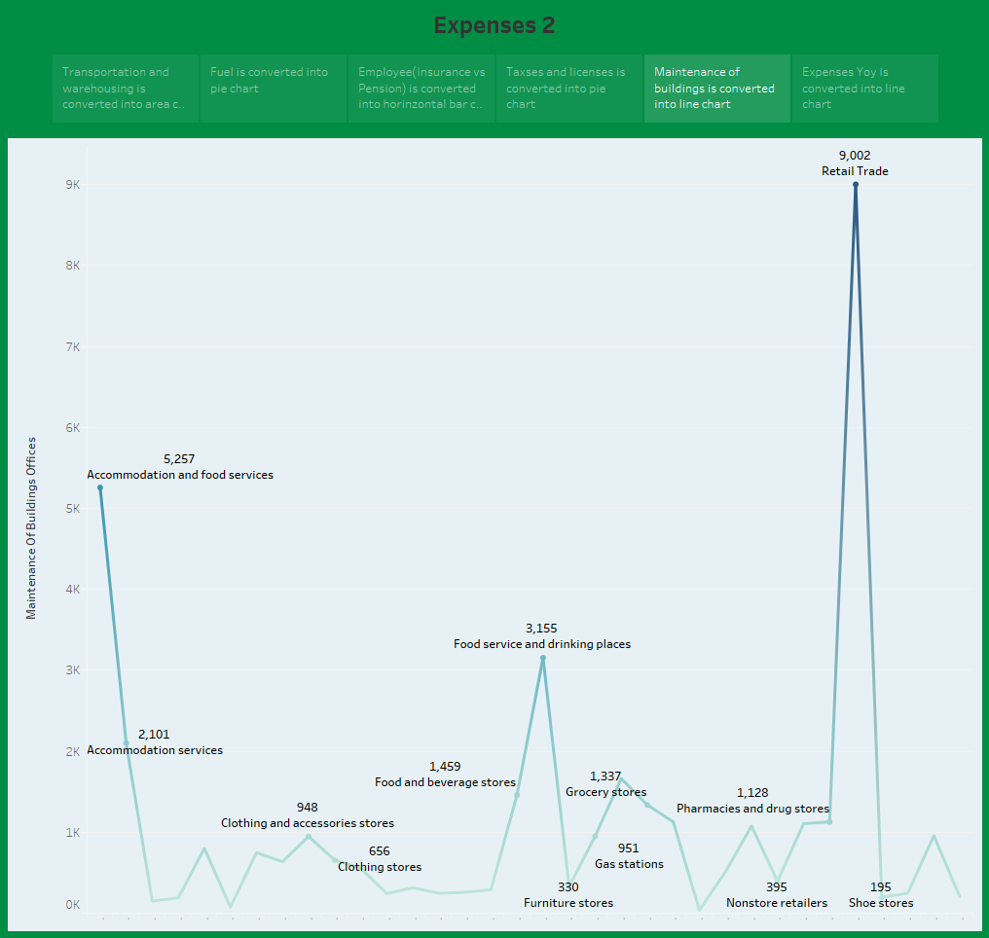

4 ADVANTAGES & DISADVANTAGES

4.1 Advantages

• Cost estimation helps you determine your project's budget,

• schedule the work necessary and manage new resources.

• Cost estimates are also very crucial when it comes to winning new

business.

• Property owners also use cost estimates to assess the feasibility of their

projects before embarking on actual construction.

4.2 Disadvantages

• It can be expensive to implement and it is time-consuming.

• It is not flexible enough to answer what-if questions.

• New estimates must be built for each alternative.

• The product specification must be well-known and stable.

5 APPLICATIONS

• Estimates are important because they allow businesses to set expectations for their customers.

• They also help businesses determine whether or not a project is feasible and how much profit they can expect to make.

• Estimating also allows businesses to plan for unforeseen expenses and keep track of spending.

6 CONCLUSION

This involves estimating all the expenses required to start and operate the

business, such as equipment, rent, inventory, and marketing. By calculating these costs upfront, business owners can better plan their budget and avoid unexpected expenses.

1. FUTURE SCOPE

Estimation engineers will also be able to use new software to help them with their work. This software will allow them to create more accurate estimates and save time on their projects.

**THANK YOU.**